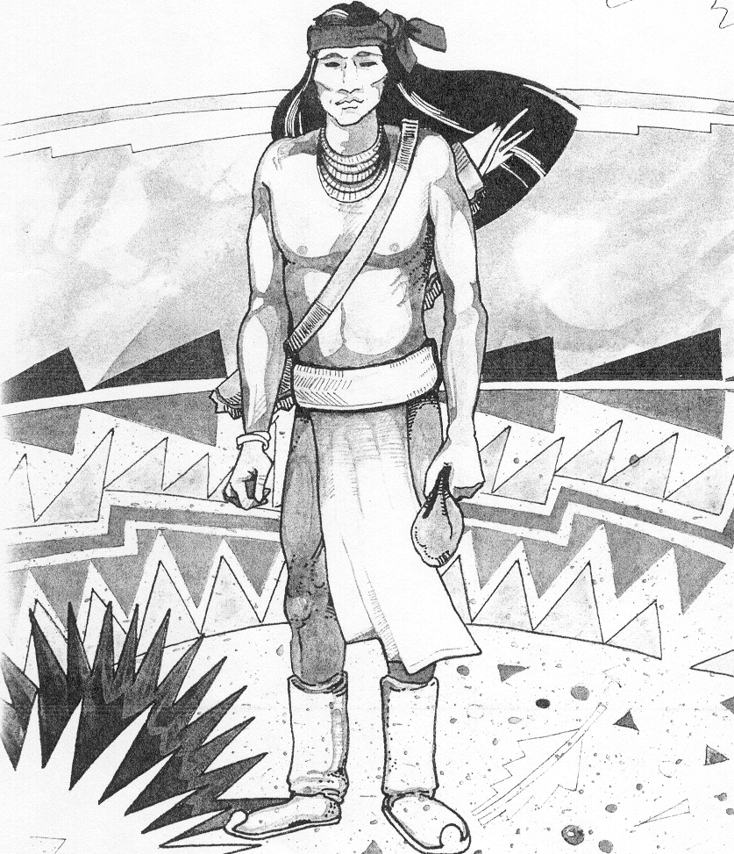
Cochise School District No. 26

5025 N. Bowie Ave.
P.O. Box 1088
Cochise, AZ 85606
(520) 384-2540 (520) 384-4836 Fax

Karl Uterhardt, Superintendent

Dear parents/guardians: August 22, 2022

With the start of a new school year it is important we are all are on the same page for the success and safety of our students and staff. Please keep your student(s) home if they are sick with flu like symptoms including:
- Fever of 100.4 degrees Fahrenheit or higher
- Chills
- Shortness of breath or difficulty breathing
- Fatigue
- Muscle or body aches
- Headache
- New loss of taste or smell
- Sore throat
- Congestion or runny nose
- Nausea or vomiting
- Diarrhea
- Any other symptom of illness, whether or not you believe it’s related to COVID-19
A positive Covid test will require your student to be placed on a five (5) day quarantine or until they are 24 hours without a fever. Please keep your other children home to prevent the spread if someone in your household has Covid. Your student’s teacher(s) will have Google Classroom online, as we have for the past two years, so your child may keep up with their work and they will have several days to make up their work upon their return to school. If your student becomes ill at school, please come and pick them up within one (1) hour of the phone call. If a student in your child’s class tests positive for Covid, the school will inform the other students’ parents that a student in your child’s class tested positive for Covid.
Thank you for your assistance and cooperation in this matter. I know it is going to be an outstanding school year!

Sincerely,

Karl Uterhardt

